Retractable Roof/Enclosure Questionnaire
Title | Details
Type of Roof
  Top roof | 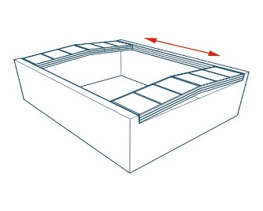
  Partial retractable enclosure | 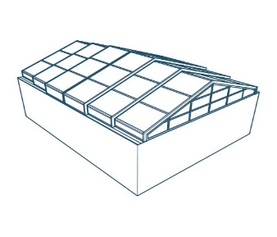
  Complete retractable enclosure | 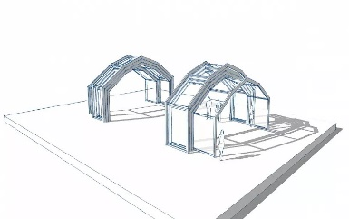
  Fixed Roof
Type of Material | Polycarbonate + Al | Glass + MS | Fabric + AL
Operation
  Automatic | Manual | Fixed
  Remote | Pendant
Clear opening area  (Cut out area)
  Dimensions | Inner | Outer
  Length
  Width
  Height
Opening option
  Centre opening | One side
Stacking place available (outside the cut out)
  If Yes, how much? | NO
Supporting structure present at site
  Yes | No
    Client | NIHVA
Colour specification Aluminium profile
  Powder coat code (RAL)
Polycarbonate sheet option
  Clear | Embossed | Tinted
No. Of expected cycles in a day
AMC required (Tenure)
  Years | Visits/year
Wind pressure at site
Additional remark
CAD file/Layout plan
Site photographs

